Business Continuity Plan Template for
LPL Financial &
THE Financial Services Network
Non-OSJ Branch Offices

ENTER Non-OSJ BRANCH NAME HERE
Business Continuity Plan (BCP)

Notes and Instructions:
- This document requires revisions from your firm before it is complete.
- Replace all RED Highlighted sections with the correct language pertinent to your firm.
- Delete all YELLOW highlighted sections as they will not be needed when you print the document.
- This document is a Business Continuity Plan (BCP - aka Disaster Recovery Plan) and does not address succession planning or movement of your client assets to another advisor in the event of your death or disability. There are other plans for those scenarios that can be addressed by calling THE Financial Service NETWORK at 650-571-1934.
- Keep a copy of this document with your Compliance files as well as a copy away from the premises of your business such as at your home or scanned and saved to your computer.
- This BCP has been customized for affiliates of THE Financial Services NETWORK. If you have this document and are not an affiliate of THE NETWORK, please call 650-571-1934.

Template Dated – 5/23/2011

Table of Contents

I. Introduction 1
II. Emergency Contact Persons 1
III. Branch Policy 1
IV. Business Description 2
V. Office Locations 2
VI. Alternative Physical Location(s) of Employees 2
VII. Customers’ Access to Funds and Securities 3
VIII. Data Back-Up and Recovery (Hard Copy and Electronic) 3
IX. Financial and Operational Assessments 4
X. Mission Critical Systems 4
XI. Alternate Communications Between the Firm and Customers, Employees, and Regulators 6
XII. Critical Business Constituents, Banks, and Counter-Parties 6
XIII. Regulatory Reporting 7
XIV. Disclosure of Business Continuity Plan 7
XV. Updates and Annual Review 7
XVI. Branch Manager Approval 8
Appendix A - Employee Roster
Appendix B - Critical Business Partners
Appendix - c - LPL Financial Business Continuity Plan
Appendix -D - Record of Annual Review

Introduction
This manual documents the business continuity plan for [Insert Branch or DBA Name]. The purpose of this manual is to document the plans for the recovery of our critical business functions and systems in the event of a business disruption.

Emergency Contact Persons
LPL Financial provides FINRA with the contact information for two emergency contact persons to fulfill this requirement for all branch office locations under LPL Financial. These two emergency contact persons are registered principles for LPL Financial. LPL Financial stays in compliance by updating this information upon any material change and reviewing the information quarterly to ensure it is up to date.

Rule: FINRA Rule 4370(f); NASD Rule 1160.

Branch Policy
Our non-OSJ branch’s policy is to respond to a Significant Business Disruption (SBD) by safeguarding employees’ lives and our property, making a financial and operational assessment, quickly recovering and resuming operations, protecting all of our branch’s books and records, and allowing our customers to transact business. In the event that we determine we are unable to continue our business at this branch office, we will direct our customers to the following:
The Financial Services NETWORK for questions and status at (800) 736-9616
LPL Financial at: (800) 877-7210 for emergency assistance and to access to client funds.

Significant Business Disruptions (SBDs)
Our plan anticipates two kinds of SBDs, internal and external. Internal SBDs affect only our branch’s ability to communicate and do business, such as a communications failure or a fire in our building. External SBDs prevent the operation of the securities markets or a number of branches, such as a terrorist attack or a wide-scale, regional disruption. Our response to an external SBD relies more heavily on other organizations and systems, especially on the capabilities of LPL Financial.

Approval and Execution Authority
Non- OSJ BRANCH MANAGER NAME is responsible for approving the plan and for reviewing it in the registered location annually and with employees of the registered location. The non-OSJ Branch Manager has the authority to execute this BCP and notify THE NETWORK home office at 800-736-9616 upon execution.

Plan Location and Access
The non-OSJ branch office will maintain copies of its BCP plan and the annual reviews, and the changes that have been made to it for inspection. An electronic copy of our plan is also located in THE NETWORK Office of Supervisory Jurisdiction.

Rule: FINRA Rule 4370(b), (d) and (e).

Business Description
The non-OSJ branch office primarily conducts securities business on behalf of clients, their businesses, and their families.

LPL Financial is our affiliated broker-dealer and performs many back-office and support related functions such as custodial and clearing of client accounts. All transactions are sent to LPL Financial, which executes our orders, compares them, allocates them, clears and settles them. LPL Financial also maintains our customers’ accounts, can grant customers access to them, and delivers funds and securities. In some cases, our office may have relationships with third parties which custody assets elsewhere such as a trust company.

LPL Financial is located at:
Boston  LPL Financial  One Beacon Street  22nd Floor  Boston, MA 02108 | Charlotte  LPL Financial  Five Coliseum Centre  2810 Coliseum Centre Dr.  Charlotte, NC 28217 | San Diego  LPL Financial  9785 Towne Centre Drive  San Diego, CA 92121

Our contact number for LPL Financial is: (800) 877-7210

Non-OSJ Branch Office Locations
Our main registered office location is:

Office Location #1
[INSERT BRANCH NAME & ADDRESS]
[INSERT TELEPHONE NUMBER]
[INSERT FUNCTIONS PERFORMED AT THIS LOCATION]

Office Location #2

Complete if applicable. If not applicable delete.
[INSERT BRANCH NAME & ADDRESS]
[INSERT TELEPHONE NUMBER]
[INSERT FUNCTIONS PERFORMED AT THIS LOCATION]

Alternative Physical Location(s) of Employees
In the event of an SBD, we will move our staff from affected office(s) to the closest of our unaffected office location(s). If none of our other office locations is available to receive those staff, we will move them to:
[INSERT ADDRESS]
[INSERT TELEPHONE NUMBER]

Rule: FINRA Rule 4370(c)(6).

Customers’ Access to Funds and Securities
LPL Financial maintains custody of customers’ funds or securities on our behalf. In the event of an internal or external SBD, if telephone service is available, our registered persons will take customer orders or instructions and contact LPL Financial on their behalf, and if our Web access is available, our branch will post on our website that customers may access their funds and securities by contacting LPL Financial at: (800) 877-7210.

If the Securities Investor Protection Corporation (SIPC) determines that we are unable to meet our obligations to our customers or if our liabilities exceed our assets in violation of Securities Exchange Act Rule 15c3-1, SIPC may seek to appoint a trustee to disburse our assets to customers. We will assist SIPC and the trustee by providing our books and records identifying customer accounts subject to SIPC regulation [and insert any additional procedures].

Rules: FINRA Rule 4370(a); Securities Exchange Act Rule 15c3-1; see also 15 U.S.C. § 78eee.

Data Back-Up and Recovery (Hard Copy and Electronic)

Our branch maintains its primary hard copy books and records at:
[INSERT NAME AND ADDRESS]

(if applicable)Our branch maintains its primary electronic backup disks/hard drives at:
[INSERT NAME AND ADDRESS]

(if applicable)Our branch maintains its primary web-based electronic records with the following service:
[INSERT NAME and web address

[Name, title, phone number] is responsible for the maintenance of all non-OSJ Branch books and records.

(if applicable)Our branch maintains some hard copy books and records offsite at:
[INSERT NAME AND ADDRESS]
Responsible Party: [INSERT NAME OF PERSON RESPONSIBLE FOR BACK UP]

(if applicable) Our branch maintains backup electronic records at:
[INSERT NAME AND ADDRESS]
Responsible Party: [INSERT NAME OF PERSON RESPONSIBLE FOR BACK UP]
Backup Frequency: [Insert frequency records are backed up]
Format:[Disk, hard drive, etc…]

In the event of an internal or external SBD that causes the loss of our paper records, we will physically recover them from our backup or electronic copies. If our primary site is inoperable, we will continue operations from our back-up site or an alternate location. For the loss of electronic records, we will either physically recover the storage media or electronically recover data from our back-up site, or, if our primary site is inoperable, continue operations from our back-up site or an alternate location.

Rule: FINRA Rule 4370(c)(1).

Financial and Operational Assessments

Operational Risk
In the event of an SBD, we will immediately identify what means will permit us to communicate with our customers, employees, critical business constituents, critical banks, critical counter-parties and regulators. In addition, we will retrieve our key activity records as described in the section above, Data Back-Up and Recovery (Hard Copy and Electronic). If needed, we will direct customers directly to the following:
The Financial Services NETWORK for questions and status at (800) 736-9616
LPL Financial at: (800) 877-7210 for emergency assistance and to access to client funds.

Rules: FINRA Rules 4370(c)(3),(c)(4), (c)(5), (c)(7), (c)(9 & (g)(2)).

Financial and Credit Risk
In the event of an SBD, we will determine the value and liquidity of our investments and other assets to evaluate our ability to continue to fund our operations and remain in capital compliance. We will contact LPL Financial, critical banks and investors to apprise them of our financial status. If we determine that we may be unable to meet our obligations to those counter-parties or otherwise continue to fund our operations, we will request additional financing from our bank or other credit sources to fulfill our obligations to our customers and clients. If we cannot remedy a capital deficiency, we will file appropriate notices with our regulators and immediately take the appropriate steps.

Rules: FINRA Rules 4370(c)(3), (c)(8) & (g)(2).

Mission Critical Systems
“Mission critical systems” are those that ensure prompt and accurate processing of securities transactions, including order taking, entry, execution, comparison, allocation, clearance and settlement of securities transactions, the maintenance of customer accounts, access to customer accounts and the delivery of funds and securities.

We have primary responsibility for establishing and maintaining our business relationships with our customers and have sole responsibility for our mission critical functions of order taking, entry and execution. LPL Financial provides the execution, comparison, allocation, clearance and settlement of securities transactions, maintenance of customer accounts, access to customer accounts and the delivery of funds and securities.

Our Branch’s Mission Critical Systems

Order Taking
Currently, we receive orders and instructions from customers via telephone or in-person. We also receive client paperwork via fax, encrypted e-mail, in person or through a secure website portal. During an SBD, either internal or external, we will continue to take orders through any of these methods that are available and reliable, and in addition, as communications permit, we will inform our customers when communications become available to tell them what alternatives they have to send their orders to us. If customers are unable to reach the branch to place trades they can contact LPL Financial’s Service Center at (800) 877-7210.

Order Entry
Currently, we enter orders electronically and send them to LPL Financial electronically through BranchNet or telephonically. LPL Financial represents under its BCP, we can expect service restoration within 4 Hours.

In the event of an internal SBD, we will enter and send records to LPL Financial by the fastest alternative means available, which include telephone or BranchNet. In the event of an external SBD, we will maintain the order in electronic or paper format, and deliver the order to LPL Financial by the fastest means available when it resumes operations. In addition, during an internal SBD, we may need to refer our customers to deal directly with LPL Financial for order entry.

Order Execution
LPL Financial executes orders on our behalf. LPL Financial’s Charlotte and San Diego offices serve as primary locations for Trade Execution. Each office serves as the backup for the other. There are documented and tested plans in place to provide for a fail-over between the two sites.

Other Services Currently Provided to Customers: IF YOU DON’T PROVIDE ADDITIONAL SERVICES TO YOUR CLIENTS DELETE THIS SECTION.
In addition to those services listed above in this section, we also [describe any other services you provide customers]. In the event of an internal SBD, we would [describe how you would provide those services in the event of an internal SBD]. In the event of an external SBD, we would [describe how you would provide those services in the event of an external SBD].

Mission Critical Systems Provided by LPL Financial
Our branch relies on LPL Financial to provide order execution, order comparison, order allocation, customer account maintenance and/or access and delivery of funds and securities.

LPL Financial backs up certain client records at a remote site. LPL Financial’s Charlotte and San Diego offices serve as primary locations for mission-critical processing, including: Operations, Trade Execution and Processing, and the Service Center. Each office serves as the backup for the other. There are documented and tested plans in place to provide for a fail-over between the two sites.

Rules: FINRA Rules 3510(c)(2) & (g)(1).

Alternate Communications Between the Firm and Customers, Employees, and Regulators

A. Customers

We now communicate with our customers using the telephone, e-mail, our website, fax, U.S. mail and in-person visits at our office or another location. In the event of an SBD, we will assess which means of communication are still available to us, and use the means closest in speed and form (written or oral) to the means that we have used in the past to communicate with the other party. For example, if we have communicated with a party by e-mail but the Internet is unavailable, we will call them on the telephone and follow up where a record is needed with paper copy in the U.S. mail.

Rule: FINRA Rule 4370(c)(4).

B. Employees (See Appendix A)

We now communicate with our employees using telephone, e-mail, and in person. In the event of an SBD, we will assess which means of communication are still available to us, and use the means closest in speed and form (written or oral) to the means that we have used in the past to communicate with the other party. We will also employ a call tree so that senior management can reach all employees quickly during an SBD. The call tree includes all staff home and office phone numbers. We have identified persons, noted below, who live near each other and may reach each other in person.
Rule: FINRA Rule 4370(c)(5).

C. Regulators

We communicate with our regulators using telephone, e-mail, fax, U.S. mail and in person.. In the event of an SBD, we will assess which means of communication are still available to us, and use the means closest in speed and form (written or oral) to the means that we have used in the past to communicate with the other party.

Rule: FINRA Rule 4370(c)(9).

Critical Business Constituents, Banks, and Counter-Parties (See Appendix B)

Business constituents
Critical business constituents are businesses with which we have an ongoing commercial relationship in support of our operating activities such as vendors providing critical services.

LPL Financial provides most of our critical services. We will quickly establish alternative arrangements if a business constituent can no longer provide the needed goods or services when we need them because of a SBD to them or our firm.

Our other critical business constituents are:

Rules: FINRA Rule 4370(c)(7).

Banks
We have contacted our banks and lenders to determine if they can continue to provide the financing that we will need in light of the internal or external SBD.

Rules: FINRA Rule 4370(c)(7).

Counter-Parties
LPL Financial maintains the relationships with our critical counter-parties on our behalf. Where the transactions cannot be completed, we will work with LPL Financial or contact those counterparties directly to make alternative arrangements to complete those transactions as soon as possible.

Rules: FINRA Rule 4370(c)(7).

Regulatory Reporting

Describe how your firm will file its regulatory reports in the event of an SBD.

We are subject to regulation by the SEC, FINRA and additional federal, self-regulatory and state securities regulators as applicable. We now file reports with our regulators using paper copies in the U.S. mail, and electronically using fax, e-mail and the Internet. In the event of an SBD, we will check with the SEC, FINRA and other regulators to determine which means of filing are still available to us, and use the means closest in speed and form (written or oral) to our previous filing method. In the event that we cannot contact our regulators, we will continue to file required reports using the communication means available to us.

Rule: FINRA Rule 4370(c)(8).

Disclosure of Business Continuity Plan

LPL Financial has a BCP disclosure statement that is provided to our customers at account opening and attached to this document as “Appendix C”. The BCP Disclosure statements is also posted to www.lpl.com and mailed to customers upon request.

Rule: FINRA Rule 4370(e).

Updates and Annual Review (See Appendix D)

We will update this plan whenever we have a material change to our operations, structure, business or location or to those of LPL Financial. In addition, our firm will review this BCP annually to modify it for any changes in our operations, structure, business or location or those of LPL Financial.

Rule: FINRA Rule 4370(b).

Non-OSJ Branch Manager Approval

I have approved this Business Continuity Plan as reasonably designed to enable our branch to meet its obligations to customers in the event of an SBD.

Rule: FINRA Rule 4370(d).

Signed (non-OSJ Branch Manager): _______________________________

Title: _______________________________

Date: _______________________________

Appendix A

Employee Roster

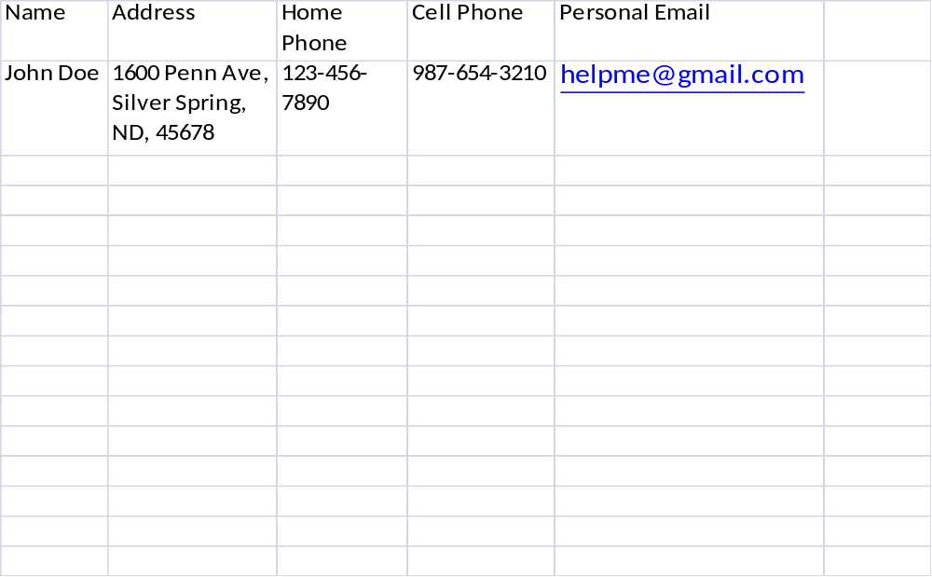

Appendix B

Critical Business Constituents

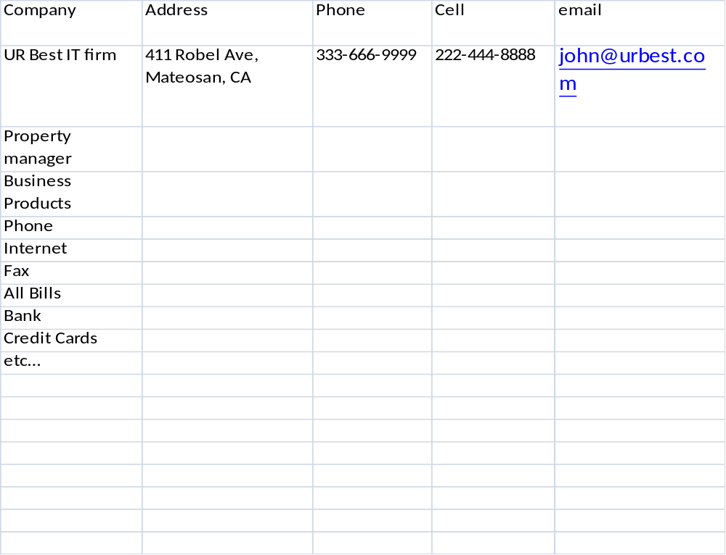

Appendix C
LPL Financial & Affiliate
Business Continuation Plan Summary

LPL Financial and our affiliates—UVEST Financial Services and The Private Trust Company—are committed to providing timely service to our clients. We recognize the importance of preparing for various disaster scenarios that could hamper our ability to provide service. We have taken aggressive steps to provide for business contingency and continuity planning under a variety of potential scenarios. We continue to evaluate our continuity plans and take the necessary actions to ensure the proper resources are available to provide for the recovery and timely resumption of critical business operations to internal business units, third-party business partners, and clients.

LPL Financial Business Continuation Strategy

Headquarters and Staff
LPL Financial has headquarters and operations staff located in three principal locations: Boston, Charlotte, and San Diego. The Boston office serves as the primary site for our executive office, Legal, and Research. These units, while vital to the company on a continuing basis, are not considered mission-critical for the daily back-office operation of our business. In the event of a disaster that would make the Boston office unserviceable, the San Diego office is its alternative facility.

Mission-Critical Departments
Both the Charlotte and San Diego offices serve as primary locations for our mission-critical departments, including: Operations, Trade Execution and Processing, and the Service Center. Each office serves as the backup for the other. There are documented and tested plans in place to provide for a fail-over between the two sites.

The LPL Financial Production Data Center is located in a second and distinct Charlotte location. The alternate Data Center is located within the firm’s San Diego location.
- The Production Data Center facility is located approximately two miles from the Charlotte office location.
- The Production Data Center infrastructure is fully redundant in terms of power, network, and equipment.
- The seven buildings at the San Diego location also have fully redundant networking and telecommunications systems.
- There is redundant connectivity across Boston, Charlotte, and San Diego.

The LPL Financial brokerage computing platform is operated in another geographical region of the United States by an unaffiliated third-party vendor. None of the scenarios presented in this document would pose a threat of business disruption to this remote site. The third-party vendor has a complete business continuity plan that includes alternative sites and recovery times within four hours.

Business Scenario Preparedness
Single Building Disruption
If LPL Financial loses the ability to perform business in one of our buildings, recovery staff associated with mission-critical functions will begin processing at our alternate processing site (Boston, Charlotte, or San Diego, depending on the impacted department). We have plans in place for this relocation, and these plans are tested periodically. Recovery time objectives vary based on the criticality of the function that is disrupted.

Campus Disruption
If LPL Financial loses the ability to perform business at either the Charlotte or San Diego location, mission-critical San Diego functions would be failed over to our Charlotte office and vice versa. Staff associated with non-mission-critical functions will be relocated to an alternative site (e.g., hotel, home) in an unaffected area. We have plans in place for this relocation and they are tested periodically. Recovery time objectives vary based on the criticality of each function.

Remote Data Center Disruption
If LPL Financial loses the ability to perform business in our Production Data Center in Charlotte, mission-critical systems will be recovered to our San Diego Data Center. We have plans in place for this recovery and they are tested periodically. Mission-critical systems recovery is expected within four hours.

Pandemic Event
LPL Financial has plans in place to continue business during a pandemic event. Our plan is a multi-tiered action plan based on the World Health Organization (WHO) alert phases with triggering events for each phase. As the threat of a pandemic becomes greater and a new phase is triggered, we will assess our plans and determine the appropriate course of action.

Access to Your Funds
A site outage should not impact our customers’ ability to access to their available funds, as LPL Financial business contingency plans are designed to ensure sustained service. However, their ability to trade securities may be impacted by market events outside the control of LPL Financial, such as when the market was closed following the September 11 tragedy. Our tested business continuity plans result in necessary personnel being available to approve transactions that result in the disbursement of available funds. In the event that your LPL Financial advisor ceases operations due to a significant business interruption, you may call (800) 877-7210 for emergency assistance.

Conclusion
Please be aware that, while we have detailed plans in place, we cannot guarantee that we will be successful in achieving recovery in the times noted above. For example, we may not be able to implement a plan during a disaster as quickly as we expect, or there may be disasters that we have been unable to anticipate and for which we have no plan. Additionally, if parts of our plan are dependent upon third parties, we will have no control over the success or failure of the third party to respond appropriately to the challenges posed at the time of the disaster. Our continuity plans are periodically updated and modified. Updated plan summaries will be made available on our website (www.lpl.com) and can be obtained by submitting a written request.

Appendix D

Annual Notice of Review

Date Name of Reviewer Signature

__________________________________________________________________________

__________________________________________________________________________

__________________________________________________________________________

__________________________________________________________________________

__________________________________________________________________________

__________________________________________________________________________

__________________________________________________________________________

